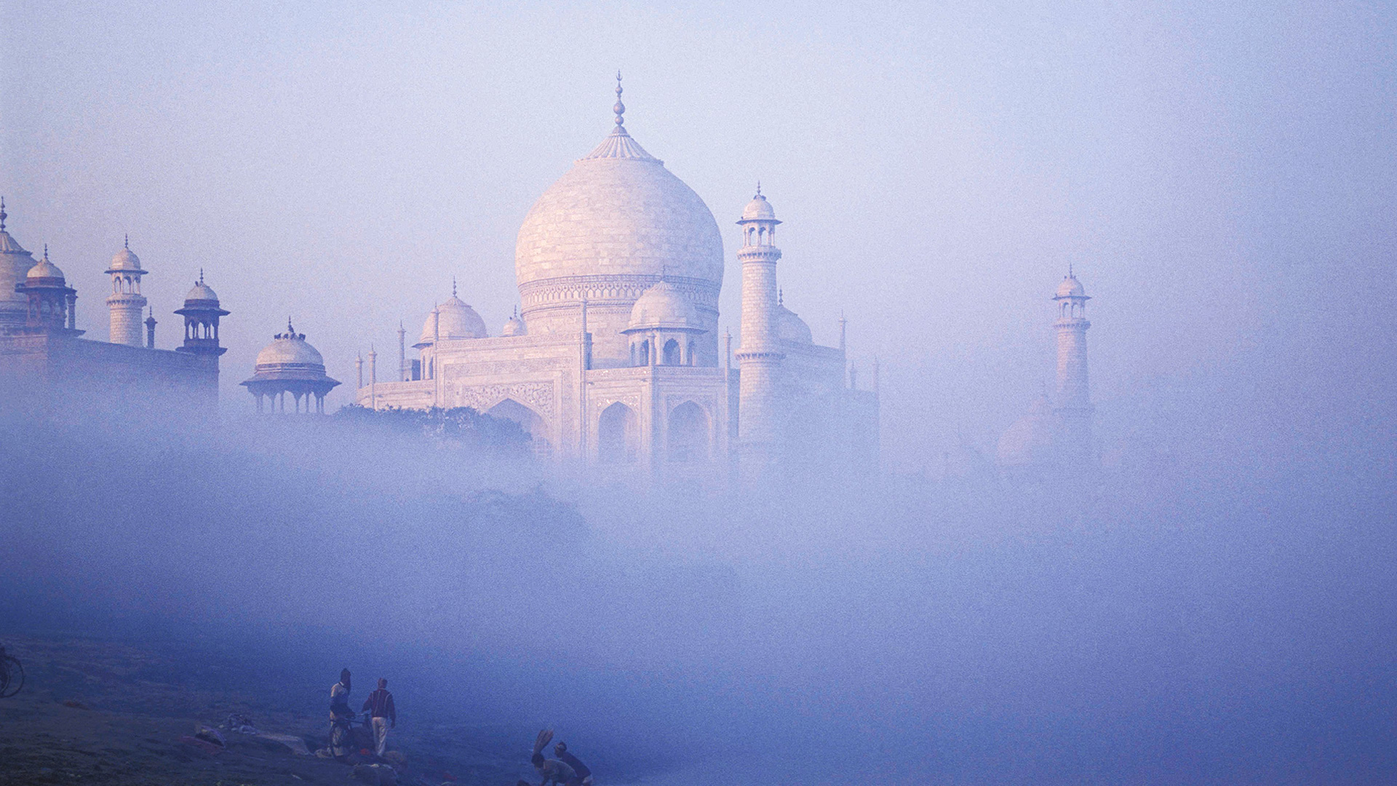

As an intersex person, Gopi faced a lot of harassment in his younger years to the point where he had to discontinue his studies. As a way of fighting back he began a welfare group that works with gender and sexual minorities. Since then Gopi has been leading several LGBTQIA initiatives in Tamil Nadu and was given the Diversity Leadership Award earlier this year by the World HRD Congress. Zis book, titles “Maraikappata Pakkangal” (Hidden pages) is the first book on gender variants in Tamil. Gopi’s intervention through Srishti Madurai has created a larger impact on the welfare of gender minorities and government’s policy regarding them.

Gopi Shankar Madurai is the founder of Srishti Madurai, non-funded student organization that counts amongst its members human rights activists, independent scholars, and gender queer activists who spread more awareness about the LGBTQIA community. Srishti Madurai runs a 24×7 helpline and provides face-to-face counseling services to community members in need. It also has resources, research material, and literature on LGBTQIA.

Started in 2011, Srishti Madurai goes to schools and colleges and conducts seminars and workshops to not just raise awareness but also make the younger generation more empathetic towards the often-stigmatized LGBTQIA community.

Gopi Shankar is involved in rescuing transgender individuals from forced sex work & forced begging, he has also organized rehabilitation camps for Child Labors to reinstate them in mainstream society. Shankar wrote the first book on gender variants, in Tamil and coined dignified Tamil regional terms for them. He was invited to the upper house of the Parliament of India to witness to the passing of transgender bill.

Gopi believes that the poor and the underprivileged section creates most of India’s sportspersons so to discover the inner potential of Indian Tamil girls in International arena to celebrate, encourage, train and share their spirit and participation in International sports he started Srishti Madurai Sports Initiative to "Ensure Childhood for All Children" & to use "Sports as a tool for social change".

This initiative gives major importance to woman students. Hence it contributes to the woman empowerment, especially targeted at the rural woman. This initiative provides occasional training for outside students and thus contributing their development in the art of sports. These girls are either orphans or come from BPL, broken or socially discriminated families whose education and health is now fully taken care of by Srishti Madurai Sports Initiative by Gopi Shankar Madurai. This initiative is self-funded and collaborates with various organizations. At present Gopi is looking for capital to start a social entrepreneurship model to support & fund this initiative of Srishti Madurai.

Gopi Shankar was born in Madurai on 13.4.1991 joined as a monk, pre-probationer of Sri Ramakrishna Math and left the RKM in 2011. At the age of 14 he started volunteering Sri Ramakrishna Mission and he was the Volunteer Coordinator & Events Coordinator for National Youth Day Celebration in which more than 200000 students took part so far. At the age of 19 he founded the Srishti Madurai non-funded student organization, Gopi is youngest panelist to share chair in University Grants Commission of India (UGC) and Indian Council of Social Sciences Research (ICSSR) sponsored National Seminars in India, he conducted more than 85 Seminars, Interactive sessions on Gender & Sexuality for 8000 students in Madurai. Gopi coined the regional Tamil terms for Genderqueer people & wrote the first book on Gender-Variants in Tamil. He also organized Asia's first Genderqueer Pride Parade.

# Gopi Shankar –Madurai, India