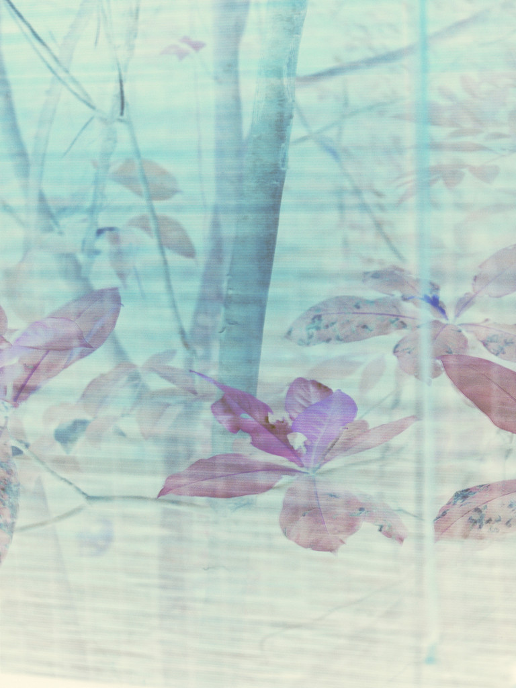

* Creating impact by reaching out to Gov. Schools and at some point partnering with the Government to integrate the program as a part of curriculum and strengthening the monitoring system to ensure the quality of the product.
* Building a revenue stream to make the program sustainable by launching FLUX as a social enterprise. The product will be an experiential learning module for children to learn creative problem solving for NGO’s, Schools & Civil Welfare Organizations.

The module aims to emerge as an anchor for the students to value their education and making learning an engaging and fun experience. Foster and Forge foundation also started an initiative called ARTWALL. Here they paint the public schools with colorful and free artworks to make the classrooms more appealing and fun for the students. They bring volunteers from all walks of life in this initiative and pair them with the kids from the school to work one frame together to build collaboration.

Foster & Forge also works with artisans and handicrafts. This November 2016 we are putting a sensorial scape art installation made of handicrafts. We are installing this in the Blind School, Delhi where people will experience Indian handicrafts through all senses for the first time; apart from visual, auditory, touch & feel of patterns and material, smell and taste. We work with 12 artisans across different materials and this is a unique attempt to connect two seemingly unconnected communities - Craft community & Visually Impaired Community.

✹

✹

Shweta currently works at a NGO in Noida, India, called Foster and Forge Foundation as the Social Innovator working in the domains of Livelihood and education. Shweta’s work is to design community engagement programs to bridge communities. She works with the concept of Human Centered Design which aims at designing better education, healthcare, sanitation etc.

Shweta has designed an experimental learning toolkit called FLUX, which uses a mix of arts and crafts, story telling and gamifacation to enable the children in Public Schools of urban villages in India to solve civic issues around them such as water shortage, litter and women’s issues. The program aims to make education less of an abstract concept and more of a problem-solving tool for children.

The foundation is currently running the FLUX program in 21 schools (and taking it for 41 schools by November 2016) in urban and rural villages of India, touching the lives of over 8,000 children and creating at least 300 stories of change every year by enabling the children to use design thinking to solve civic issues in their schools and communities. The program FlYX has been taken by YOUTHREACH- an NGO that works with dropouts and at-risk students in the rural areas of Rewari, Roorkee and Nalagarth. This opened revenue to stream the program. Therefor the program has immense potential in being implemented in the two routes;

**Shweta Roy Chowdhury - India**